**LIBRARY management system**

A Course Work Project Report submitted in partial fulfilment of the

requirement for the award of the degree of

**Bachelor of Technology**

**in**

**Computer Science & Engineering**

**By**

**2103A51069 S.REVANTH**

**2103A51182 P.SAI TEJA**

**2103A51569 N.SANDEEP**

**Under the guidance of**

**Madhira Srinivas, Assistant Professor**



**DEPARTMENT OF COMPUTER SCIENCE & ARTIFICIAL INTELLEGENCE**

**Ananthasagar village, Hasanparthy Mandal, Hanmakonda District – 500 376**

**(2022 - 2023)**

***ACKNOWLEDGEMENTS***

First and foremost, we express our sincere thanks for the guidance and encouragement rendered by **Madhira Srinivas, Assistant Professor** in the Department of Computer Science & Artificial Intellegence, SR University, Ananthasagar, Hanmakonda District. We extend our gratitude for his advice and guidance during the progress of this course project.

Secondly, We express our sincere thanks to **Dr. M. Shashikala, Associate Professor & Head**, Department of CS & AI, SR University who stood as silent inspiration behind this course project. Our heartfelt thanks for her endorsement and valuable suggestions.

We wish to express our profound thanks to **Dr. C. V. GURU RAO Register & Dean, School of CS & AI** for providing necessary facilities to make this course project a success.

We thank all the members of teaching and non-teaching staff members, and also who have assisted us directly or indirectly for successful completion of this course project.

Finally, We would like to express our sincere gratitude to our parents who are constantly encouraging us through-out our lives and for completion of this course project.

**2103A51069 S.REVANTH**

**2103A51182 P.SAI TEJA**

**2103A51569 N.SANDEEP**

***DECLARATION***

*We declare that the course project work entitled* ***“LIBRARY MANAGEMENT SYSTEM”*** *recorded in this course project work does not form part of any other project work. We further declare that the course project work report is based on our work carried-out at* ***“SR University, Ananthasagar Mandal, Hanmakonda District – 506 371”*** *in the first year of our B.Tech course.*

**2103A51069 S.REVANTH**

**2103A51182 P.SAI TEJA**

**2103A51569 N.SANDEEP**

***Date: 28-11-2022 Place: SR University***



**Ananthasagar, Hasanparthy Mandal, Warangal District – 506 371. www.sru.edu.in**

***CERTIFICATE***

*This is to certify that the course project report entitled* ***LIBRARY MANAGEMENT SYSTEM*** *that is being submitted by* ***S.REVANTH, P.SAI TEJA, N.SANDEEP*** *in partial fulfillment for the award of* ***B.Tech*** *in* ***Computer Science & Engineering*** *to the SR University, Ananthasagar, Hanmakonda-506371 is a record of bonafide work carried out by them under my guidance and supervision.*

**Supervisor Head**

**M. Srinivas Department of CS & AI**

**Library** Management System

**Abstract:**

A library management project that manages and stores book information.The system helps students to keep a constant track of all the books available in the library.The record of the issued book with user details can also be viewed.

**The project support following operations:**

* Issuing a book
* Returning the book
* Display student details
* Exit

This project is implemented in C language using conditional statements, loops, arrays, strings, structures and pointers. The program is a MENU driven program which keeps on executing until user selects exit option.

***INDEX***

1. **Introduction 1-4**
   1. Problem Statement
   2. System Design & Modules

**1.3** Module Details

**1.4** Software Specifications

**1.5** concepts used

1. **Coding 5-19**
2. **Outputs 20-23**
3. **Conclusion 24-25**

**Chapter-I:**

**INTRODUCTION**

**1.1 Problem statement**

Library management system is a project through which the student and staff can easily know the available books. And they can also view details of students to whom books are issued. The system helps students to keep a constant track of all the books available in the library.

**1.2 System design and modules**

Here we use Linked Lists to store the data so that we can view the data whenever we want. The application asks the person who runs the program to

-issue a book from the available books

-return the book

-display the student details who are issued by books

**1.3 Module details**

First it shows the welcome page for the user & the following steps takes place…..

**Step-1:** It shows the welcome page and ask the users to enter your choice.

**Step-2:** After entering the choice, according to the choice it will further proceed.

If user selects *choice-1*

-then available books in the library are displayed with specific book I’d and asks to enter the book I’d. And need to provide the name and email for taking book from library.

When student is issued book then immediately the book is removed from the library.

If user selects *choice-2*

-student can return the book that is issued him previously with providing his book I’d.

When student returns the book, the book is immediately added to the library.

If user selects choice-3

-the details of all the issued books along with the information.

***1.4 software specifications***

**Software & Hardware Specifications :**

**Operating system : Windows 11 Home Edition**

**Application Software : Dev C++, Version 5.11**

**Processor : Intel Core i5,10th Generation,3GHZ**

**RAM : 8GB DDR4**

**SSD : 512 GB, 2000 RPM**

**Dev C++ Editor :**

Dev C++ is a complete IDE for the [C++ language](https://www.udacity.com/course/c-plus-plus-nanodegree--nd213).

The IDE uses a MinGW port of GCC (GNU Compiler Collection) as its compiler. MinGW is a minimalist approach to write executables for Windows systems. Dev C++ is also usable with Cygwin or any other GCC-based compiler. It was first built in Delphi and was upgraded using Delphi’s latest version.

Millions of users have used [Dev C++](https://github.com/Embarcadero/Dev-Cpp/) since the first version was released back in 1998 by Bloodshed Software. Having been around for over 20 years, the IDE remains a popular learning tool for universities worldwide.

Bloodshed abandoned Dev C++ in 2006 when the team no longer had the time to support it.

**Windows 11 :**

Windows 11 is the latest major release of Microsoft's Windows NT operating system, released in October 2021. It is a free upgrade to its predecessor, Windows 10 (2015), available for any Windows 10 devices that meet the new Windows 11 system requirements.

**1.5 Concepts Used**

1.Strutures

2.Conditional statements

3. Strings

4. Functions

5. Switch cases

6. Linked l

**Chapter-II:**

**CODING**

**CODE:**

#include <stdio.h>

#include <stdlib.h>

#include <string.h>

struct book{

char name[30];

char author[30];

int id;

struct book *next;

};

struct student{

char name[30];

char email[20];

char book[20];

char a[30];

int id;

struct student *next;

};

struct book *start_lib=NULL;

struct student *start=NULL;

struct book *initialize_lib(struct book *);

struct student *book_issue(struct student *);

struct student *book_return(struct student *);

struct book *diplay_lib(struct book *);

struct book *delete_book(int);

struct book *add_book(char [],char [],int);

void display(struct student *);

int main(){

start_lib=initialize_lib(start_lib);

printf("\n\n");

printf("\t\t\t ****************************************\n");

printf("\t\t\t * *\n");

printf("\t\t\t * *\n");

printf("\t\t\t * ---------------------------- *\n");

printf("\t\t\t * WELCOME TO STUDENT LIBRARY *\n");

printf("\t\t\t * ---------------------------- *\n");

printf("\t\t\t * *\n");

printf("\t\t\t * *\n");

printf("\t\t\t ****************************************\n");

printf("\n\n");

int choice;

do{

printf("\n\n");

printf("\n\t\t\t*************************************************\n");

printf("\n\t\t\t\t MAIN MENU: ");

printf("\n\t\t\t\t 1.ISSUE OF BOOKS ");

printf("\n\t\t\t\t 2.RETURN OF BOOKS ");

printf("\n\t\t\t\t 3.DISPLAY STUDENT DETAILS ");

printf("\n\t\t\t\t 4.EXIT\n ");

printf("\n\t\t\t*************************************************\n");

printf("\n\t\t\t\t Enter your choice: ");

scanf("%d",&choice);

switch(choice){

case 1:{

start=book_issue(start);

break;

}

case 2:{

start=book_return(start);

break;

}

case 3:{

display(start);

break;

}

case 4:{

exit(1);

}

default:{

printf("\n\t\t\t\t ...Invalid Option!...\n");

printf("\n\t\t\t\t Press any key to try again: ");

getch();

}

}

}while(choice!=4);

return 0;

}

struct book *initialize_lib(struct book *start){

struct book *ptr,*new_book1,*new_book2,*new_book3,*new_book4,*new_book5;

new_book1=(struct book *)malloc(sizeof(struct book));

new_book1->next=NULL;

start_lib=new_book1;

strcpy(new_book1->name,"THE MIND AND ITS CONTROL");

strcpy(new_book1->author,"SWAMI BUDHANANDA");

new_book1->id=101;

ptr=new_book1;

new_book2=(struct book*)malloc(sizeof(struct book));

new_book2->next=NULL;

strcpy(new_book2->name,"A MILLION THOUGHTS");

strcpy(new_book2->author,"ASTHA ANAND");

new_book2->id=102;

ptr->next=new_book2;

ptr=new_book2;

new_book3=(struct book*)malloc(sizeof(struct book));

new_book3->next=NULL;

strcpy(new_book3->name,"BELIEVE IN YOURSELF");

strcpy(new_book3->author,"DR.JOSEPH MURPHY");

new_book3->id=103;

ptr->next=new_book3;

ptr=new_book3;

new_book4=(struct book*)malloc(sizeof(struct book));

new_book4->next=NULL;

strcpy(new_book4->name,"YOU CAN");

strcpy(new_book4->author,"GEORGE MATTHEW ADAMS");

new_book4->id=104;

ptr->next=new_book4;

ptr=new_book4;

new_book5=(struct book*)malloc(sizeof(struct book));

new_book5->next=NULL;

strcpy(new_book5->name,"BE STRONG(FEAR NOT)");

strcpy(new_book5->author,"SWAMI TATHAGATANANDA");

new_book5->id=105;

ptr->next=new_book5;

return start_lib;

}

struct student *book_issue(struct student *start){

struct book *ptr;

struct student *ptr2,*new_student;

int i=1,id,flag=0;

if(start_lib==NULL){

printf("\n\t\t\t\t No books left in the library to issue!\n\t\t\t\t Sorry for the inconvenience!\n");

}else{

ptr=start_lib;

printf("\n\t*************** Books Available: ****************\n");

while(ptr!=NULL){

printf("\n\t_________________________________________________\n");

printf("\n\t Book %d",i);

printf("\n\t Book Title: %s",ptr->name);

printf("\n\t Name of Author: %s",ptr->author);

printf("\n\t Book ID: %d",ptr->id);

printf("\n\t_________________________________________________\n");

ptr=ptr->next;

i++;

}

printf("\n\n\t Enter the Book ID: ");

scanf("%d",&id);

ptr=start_lib;

while(ptr!=NULL){

if(ptr->id==id){

flag=1;

break;

}

ptr=ptr->next;

}

if(flag==1){

ptr=start_lib;

while(ptr->id!=id){

ptr=ptr->next;

}

new_student=(struct student *)malloc(sizeof(struct student));

printf("\n\t Enter Student Details:\n ");

printf("\n\t Enter your Name: ");

scanf("%s",new_student->name);

printf("\n\t Enter your Email: ");

scanf("%s",new_student->email);

strcpy(new_student->book,ptr->name);

strcpy(new_student->a,ptr->author);

new_student->id=ptr->id;

new_student->next=NULL;

printf("\n\t Issue of Book ID %d done successfully!\n",new_student->id);

printf("\n\n\t*************************************************\n");

if(start==NULL){

start=new_student;

}else{

ptr2=start;

while(ptr2->next!=NULL){

ptr2=ptr2->next;

}

ptr2->next=new_student;

}

start_lib=delete_book(new_student->id);

printf("\n\n\t Press any key to go to the main menu: ");

getch();

}else{

printf("\n\t\t ...Invalid Option!...\n");

printf("\n\t\t Press any key to try again: ");

getch();

}

}

return start;

}

struct student *book_return(struct student *start){

struct student *ptr,*preptr;

char bookname[30],authorname[30];

int flag=0,id,identity,c=0,d=1;

printf("\n\n\t*************** Books Submission: ****************\n");

printf("\n\n\t Enter your Book ID: ");

scanf("%d",&identity);

ptr=start;

while(ptr!=NULL){

if(ptr->id==identity){

flag=1;

break;

}

ptr=ptr->next;

}

if(flag==1){

ptr=start;

while(ptr!=NULL){

c++;

ptr=ptr->next;

}

ptr=start;

while(ptr->id!=identity){

d++;

ptr=ptr->next;

}

ptr=start;

if( d==1 ){

printf("\n\t_________________________________________________\n");

printf("\n\t Student Name: %s",start->name);

printf("\n\t Student Email: %s",start->email);

printf("\n\t Name of Book Issued: %s",start->book);

printf("\n\t_________________________________________________\n");

printf("\n\n\t Return of Book ID %d done successfully!\n",identity);

printf("\n\n\t*************************************************\n");

strcpy(bookname,start->book);

strcpy(authorname,start->a);

id=start->id;

start=start->next;

free(ptr);

add_book(bookname,authorname,id);

}else{

ptr=start;

while(ptr->id!=identity){

preptr=ptr;

ptr=ptr->next;

}

printf("\n\t_________________________________________________\n");

printf("\n\t Student Name: %s",ptr->name);

printf("\n\t Student Email: %s",ptr->email);

printf("\n\t Name of Book Issued: %s",ptr->book);

printf("\n\t Book ID: %d",ptr->id);

printf("\n\t_________________________________________________\n");

strcpy(bookname,ptr->book);

strcpy(authorname,ptr->a);

id=ptr->id;

preptr->next=ptr->next;

free(ptr);

add_book(bookname,authorname,id);

}

printf("\n\t Thank you! \n\t Do visit again! ");

printf("\n\n\t Press any key to go to the main menu: ");

getch();

}else{

printf("\n\t Please recheck the entered ID");

printf("\n\t\t\t\tPress any key to try again: ");

getch();

}

return start;

}

void display(struct student *start){

struct student *ptr;

ptr=start;

while(ptr!=NULL){

printf("\n\t************* Details of Students: **************\n");

printf("\n\t_________________________________________________\n");

printf("\n\t\t Student Name: %s",ptr->name);

printf("\n\t\t Student Email: %s",ptr->email);

printf("\n\t\t Name of Book Issued: %s",ptr->book);

printf("\n\t\t Book ID: %d",ptr->id);

printf("\n\t_________________________________________________\n");

printf("\n\n\t*************************************************\n");

ptr=ptr->next;

}

printf("\n\n\t Press any key to go to the main menu: ");

getch();

}

struct book *delete_book(int id){

struct book *ptr,*preptr;

int c=0;

ptr=start_lib;

while(ptr!=NULL){

c++;

ptr=ptr->next;

}

if(c==1){

ptr=start_lib;

start_lib=NULL;

free(ptr);

}else if(start_lib->id==id){

ptr=start_lib;

start_lib=start_lib->next;

free(ptr);

}else{

ptr=start_lib;

while(ptr->id!=id){

preptr=ptr;

ptr=ptr->next;

}

preptr->next=ptr->next;

free(ptr);

}

return start_lib;

}

struct book *add_book(char bookname[30],char authorname[30],int id){

struct book *ptr,*new_book;

new_book=(struct book *)malloc(sizeof(struct book));

strcpy(new_book->name,bookname);

strcpy(new_book->author,authorname);

new_book->id=id;

new_book->next=NULL;

if(start_lib==NULL){

start_lib=new_book;

}else{

ptr=start_lib;

while(ptr->next!=NULL){

ptr=ptr->next;

}

ptr->next=new_book;

}

return start_lib;

}

**Chapter-III:**

**OUTPUTS**

Main menu: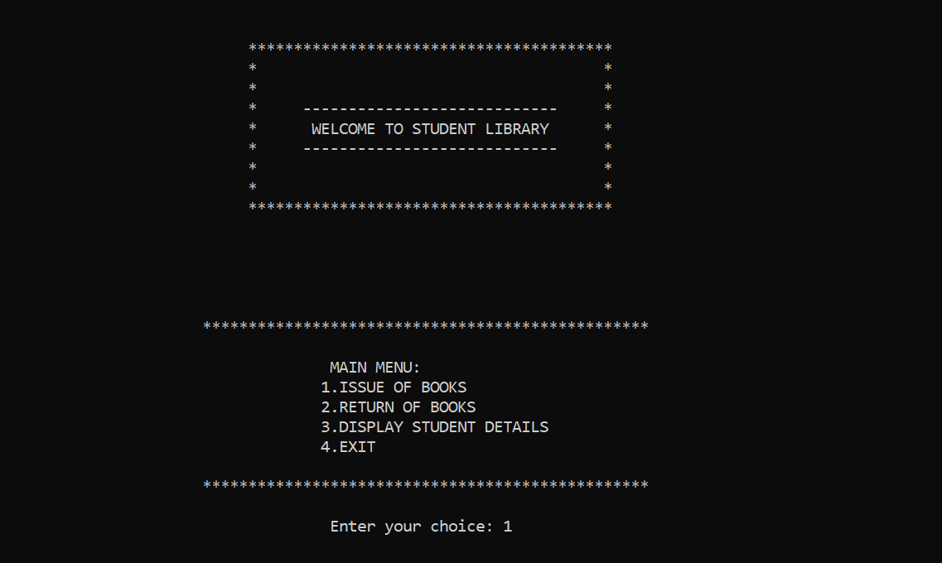

Exhibition of books

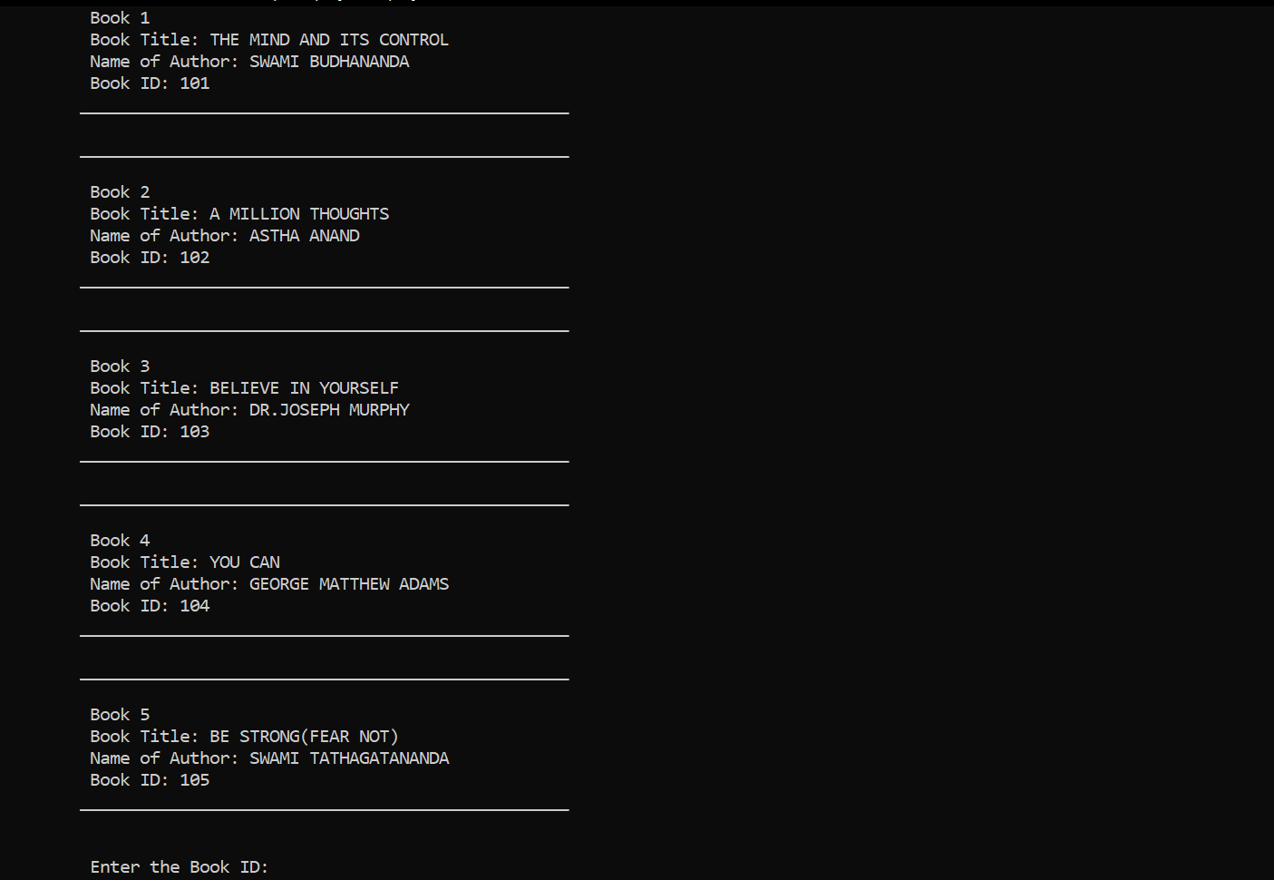

Issuing of book:

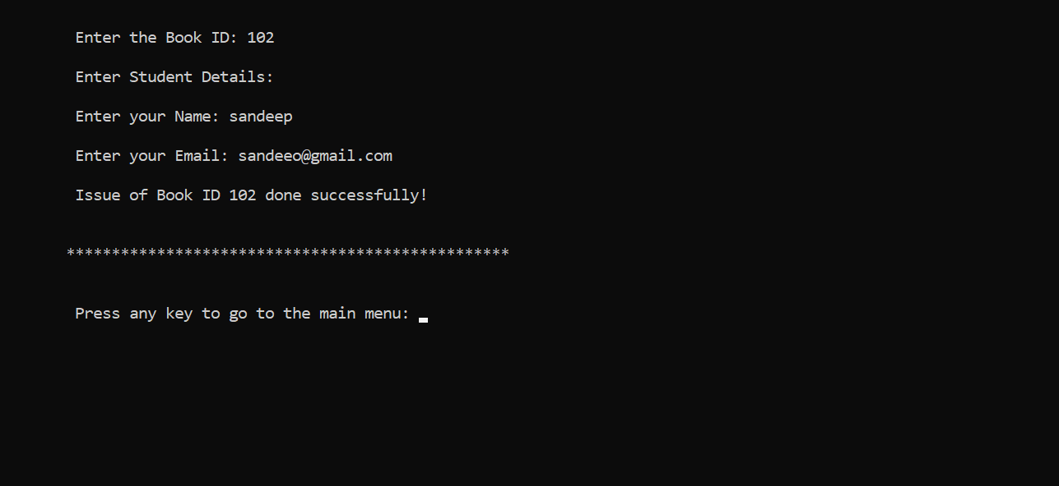

Displaying student details:

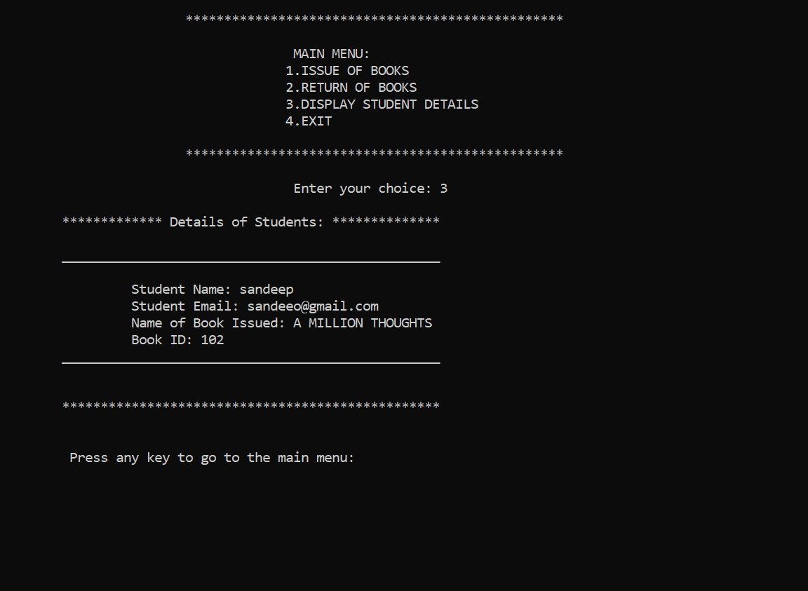

Return of book:

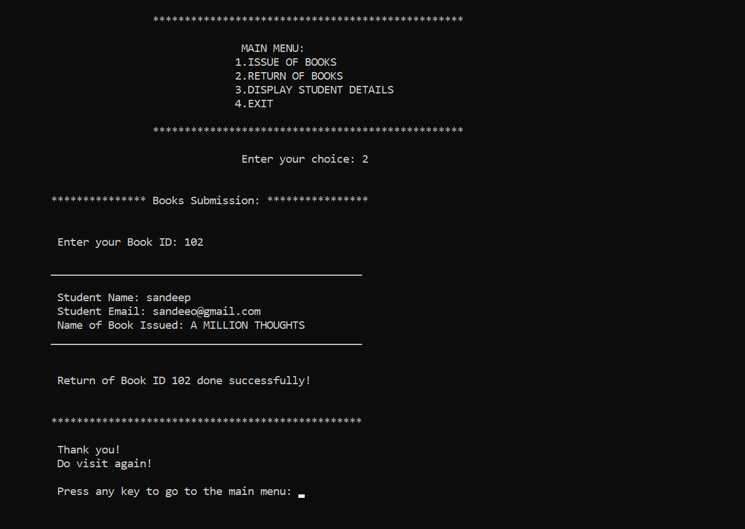

Exit:

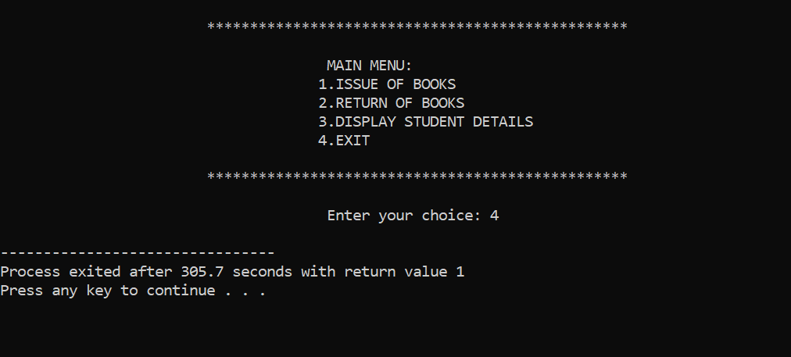

**Chapter-IV:**

CONCLUSION

**Conclusion :**

By this project we can conclude that, the staff and students can easily find the books that were issued to the students and the staff can also add any new books, through which they can update their menu. If the staff want to delete any old book they can. The students who want a book they can check the available books while they are issuing a book. Through which student and staff can manage library with ease.